Logbook and Supporting Guidance

Name: | Tutor:

Please email your completed logbook to whybror@perins.hants.sch.uk by Monday 11 July, 2022

Prepare a two-course family meal
Expedition
Read
Initiative around the house
New skill
Support your community
Energise yourself with daily exercise
Students successfully completing this award will receive a certificate and enamel pin badge.

Prepare a two-course family meal | 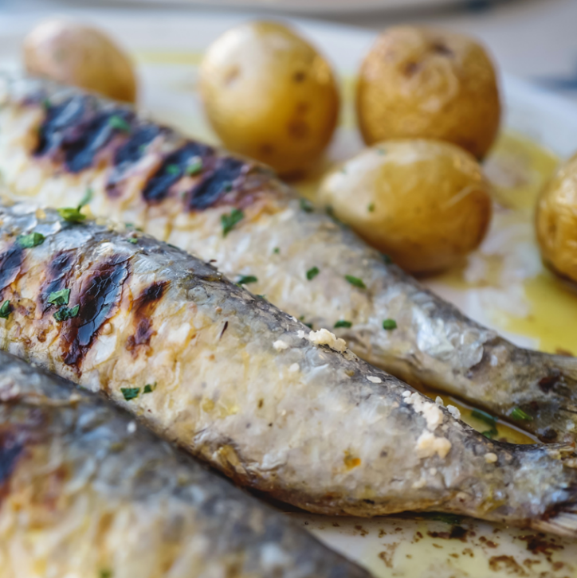
Step out of your comfort zone and prepare a high-quality main course and dessert to treat your family and to give your parents a break from their usual chores.

Guidance Notes

Discuss all plans with your parents and ensure they are in the house when you prepare the meal.

Use this box to describe the meal that you made. Include details of notable ingredients and cooking methods.

Photo 1 | Photo 2
Expedition
Plan and complete a 10KM walk with your family.

Guidance Notes

Discuss your planned route with your parents.
Use an OS map or equivalent to assist planning.
Complete the walk with your parents.
Ensure that you wear suitable footwear.
Pack sufficient layers and food.

Expedition Route:

Photo 1 | Photo 2
Read

Read a book (fiction or autobiography) and provide a written or filmed review.

Guidance Notes

Book review:

Initiative around the home | 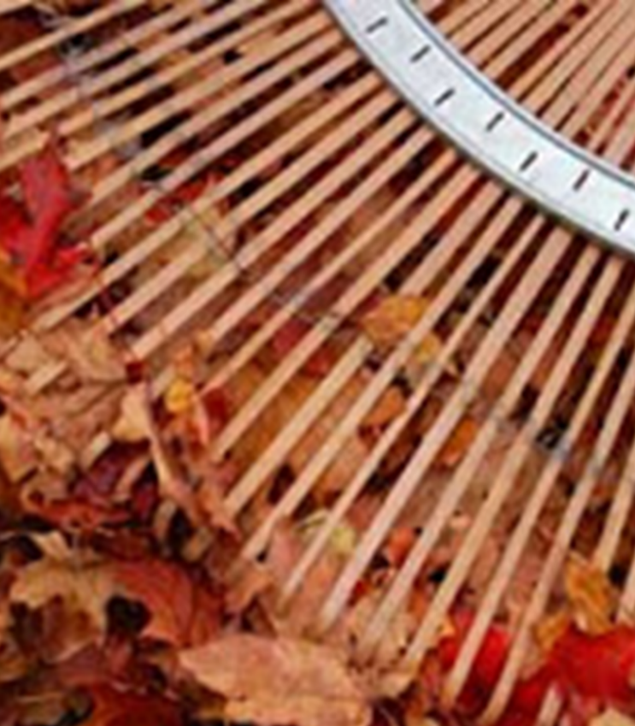
Commit to a regular household chore or complete a significant task (5 hours in total) to lighten the load for your parents.

Guidance Notes

Discuss all plans with your parents and ensure they are in the house if you are using potentially hazardous equipment.

10 mins | 10 mins | 10 mins | 10 mins | 10mins | 10 mins
10 mins | 10 mins | 10 mins | 10 mins | 10mins | 10 mins
10 mins | 10 mins | 10 mins | 10 mins | 10mins | 10 mins
10 mins | 10 mins | 10 mins | 10 mins | 10mins | 10 mins
10 mins | 10 mins | 10 mins | 10 mins | 10mins | 10 mins
Photo 1 |  |  | Photo 2
New skill

Commit to learning a skill that you haven’t previously mastered.

Guidance Notes

Commit five hours to developing this skill. Examples include sewing, knitting, baking, painting, speaking a foreign language, learning to dance, photography, learning to play chess or using computer coding.

Record details:

Photo 1 |  | Photo 2
Support the community

Complete a deed to benefit your community.

Guidance Notes

Serve your community or bring some cheer to an individual.
Ideas include taking a litter pick and bin liner on a walk to gather litter (ensure you use a litter pick and take hand gel to wash hands in the event of accidental contact with any of the litter), writing a letter to a lonely member of your family / neighbour / care home resident or delivering a food parcel to your local food bank.

Record details:

Photo 1 |  | Photo 2
Energise yourself with daily exercise

Complete at least 20 minutes of exercise every day, 6 days per week for 3 weeks.

Guidance Notes

Refer to the Core PE pages for ideas, these include walking, running, cycling, home workouts and yoga.

Week 1 | 20 mins | 20 mins | 20mins |  | 20 mins | 20 mins | 20 mins
Week 2 | 20 mins | 20 mins | 20mins |  | 20 mins | 20 mins | 20 mins
Week 3 | 20 mins | 20 mins | 20mins |  | 20 mins | 20 mins | 20 mins
Photo 1 |  |  |  | Photo 2

