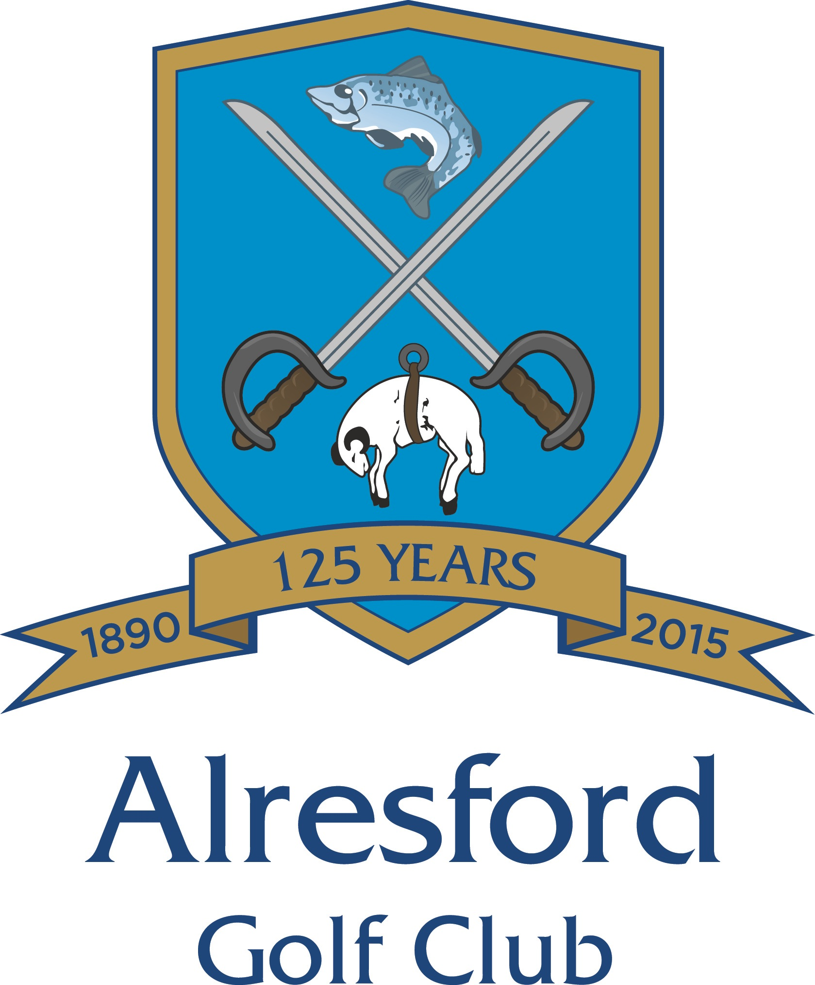

Alresford Golf Club is pleased to announce that they have been successful in its application to be a host Club for Girl Golf Rocks 2023. GGR is an England Golf initiative to encourage beginner girls, aged 5 – 18, to learn and play golf in a fun and friendly way. The programme will deliver girls only coaching sessions with an emphasis on the fun, social and friendship aspects of golf in an environment where girls feel comfortable and confident to participate.

The lessons will be delivered by the PGA golf professionals, Mark & Liam, supported by members of the Ladies section at Alresford Golf Club taking advantage of the excellent practice facilities on offer. There will be two coaching courses, the first one for girls between 5 and 11yrs of age and the second for girls aged between 12 and 18yrs of age. Each course will be preceded by a 1 hour free taster session.
The dates of the courses are:

5 to 11 yr olds
Free Taster Session Wednesday 26th April 4.30 to 5.30
Lesson 1 Wednesday 3rd May 4.30 to 5.30
Then every Wednesday between 4.30 and 5.30 up to and inc. 7th June

12 to 18 yr olds
Free Taster Session Wednesday 14th June 4.30 to 5.30
Lesson 1 Wednesday 21st June 4.30 to 5.30
Then every Wednesday between 4.30 and 5.30 up to and inc. 26th July.

The cost will be £40 per girl to include all sessions and each player will receive a a certificate of participation, a GGR polo shirt, water bottle and draw string bag.

The programme is open to all so If you have daughters, granddaughters, nieces, friends or neighbours who may wish to take advantage of this excellent opportunity we look forward to welcoming both you and them at one of the free Taster sessions.

